Literature_survey_SM_v3.0

Importance of measuring moisture at deeper soil depths

- Depth Profiling: Measurement of soil moisture at various depths within the soil profile is important because soil moisture can vary significantly with depth, and understanding moisture distribution at different depths can help with irrigation and root zone management.
- Research and Environmental Monitoring: collecting deep soil moisture level data are useful for research purposes and environmental monitoring, providing valuable data for studying soil hydrology, climate change, and ecosystem health over time.
- Root Zone Monitoring: Data about soil moisture levels in the root zone of plants is crucial for efficient irrigation management to ensure that plants receive an optimal amount of water.
- Data Consistency: Deep soil moisture measurement can help ensure more consistent data collection, as they measure moisture levels at a consistent depth, reducing variations caused by surface conditions.
- Reduced Surface Interference: Since probes are inserted deeper into the soil, reducing the impact of variations in surface conditions (e.g., evaporation) on the measurements. This can provide a more accurate representation of the moisture content at the desired depth.
- Better Drought Prediction: Measuring moisture at deeper soil depths can help in the early detection of drought conditions because changes in soil moisture at depth may precede surface indicators of drought stress in vegetation.
- Improved Water Management: deep soil moisture data can assist in optimizing water usage, especially in areas with limited water resources. They can help farmers and land managers make informed decisions about when and how much to irrigate.

Moisture measurement at deeper soil depths can be done using a long probe sensors or burying short sensors to deeper soil.However, it's important to note that both methode may have some limitations.

Limitations of sensors with long probe

- Installation Complexity: Installing long probes can be more challenging and time-consuming than installing shorter sensors. It may require specialized equipment and expertise to ensure the probes are inserted to the correct depth and positioned accurately.
- Cost: Long probes are typically more expensive than shorter sensors, both in terms of the equipment itself and the installation costs. This can be a limiting factor for some applications, particularly for small-scale or budget-constrained projects.
- Depth-Dependent Readings: Long probes primarily provide soil moisture data at the specific depth at which they are installed. If moisture levels vary significantly at different depths within the root zone, multiple probes at various depths may be needed to obtain a comprehensive understanding of soil moisture distribution.
- Limited Spatial Coverage: Long probes are typically used at specific locations, so they may not provide a broad overview of soil moisture conditions across a large area. Additional sensors or monitoring methods may be required to cover a larger geographic area effectively.
- Soil Disturbance: Installing long probes can disturb the soil, which may affect the accuracy of measurements, especially in the immediate vicinity of the probe. This soil disturbance can lead to localized changes in moisture levels.
- Sensor Drift and Maintenance: Like all soil moisture sensors, long probes can experience sensor drift over time, leading to inaccurate readings. Regular maintenance and calibration are necessary to ensure the accuracy of measurements.
- Limited Accessibility: In some cases, it may be challenging to install long probes in certain soil types or terrains. For example, rocky or compacted soils may pose difficulties in inserting the probes to the desired depth.
- Energy Requirements: Some long probe sensors require a power source, which can be a limitation in remote or off-grid locations. Battery replacement or recharging may be necessary.
- Data Interpretation: Interpreting the data from long probes can be complex, especially when there are variations in moisture levels at different depths. Data analysis and visualization tools are often required to make sense of the information collected.
- Vulnerability to Damage: Long probes extending into the soil can be vulnerable to physical damage from animals, farming equipment, or other environmental factors. This may necessitate protective measures or frequent maintenance.
- Compatibility: Integrating long probes into existing monitoring or control systems may require specialized equipment or software, which can be a disadvantage in terms of compatibility with existing infrastructure.
Limitations of Burying short sensors for soil moisture measurement
- Corrosion: Soil contains moisture and various chemicals, some of which can be corrosive. Electronic components are typically designed to resist corrosion, but over time, exposure to soil can lead to corrosion and degradation of the components' metal contacts and solder joints.
- Moisture Ingress: Soil can introduce moisture into electronic components, leading to short circuits and damage. It's essential to protect electronic components from moisture when burying them, and this may require additional waterproofing measures.
- Temperature Variations: The temperature of soil can vary significantly with depth and time of day. These temperature variations can affect the performance and reliability of electronic components, especially if they are sensitive to temperature changes.
- Mechanical Stress: The weight of the soil and any external forces can exert mechanical stress on the buried components. This stress can potentially damage or dislodge components from their intended positions, leading to malfunctions.
- Insulation Changes: Soil may alter the insulating properties of the materials used in electronic components. This could affect the electrical characteristics of the components and may lead to changes in their performance.
- Electrostatic Discharge (ESD): Depending on the composition of the soil and the grounding conditions, electronic components buried in soil may be at risk of electrostatic discharge, which can damage or disrupt their operation.
- Biological Activity: Soil contains living organisms, including microorganisms and plant roots, which may have an impact on buried electronic components. Microbial activity can lead to the deterioration of materials and potential contamination.
To mitigate these effects, if you need to bury electronic components in soil for a specific application, you should consider the following:
- Encapsulation: Use appropriate enclosures and waterproofing methods to protect the components from moisture and contaminants.
- Insulation: Ensure that the components are properly insulated and protected against potential electrical interference.
- Corrosion Resistance: Choose electronic components that are designed for outdoor or harsh environmental conditions and have good corrosion resistance.
- Monitoring and Maintenance: Regularly inspect and maintain buried components to address any issues promptly.

Some soil moisture Sensors with 1m lead

DELTA-T – PR2/6
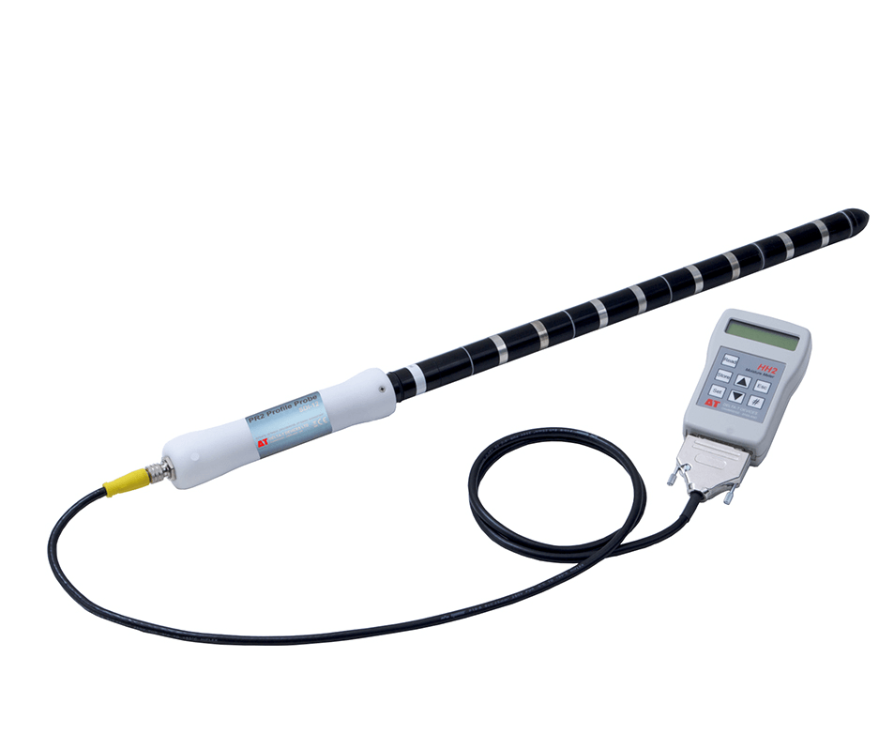

https://delta-t.co.uk/product/pr2/

PR2 soil moisture probe is built around patented sensing technology which provides unprecedented performance in all soil types, with minimal influence from either salinity or temperature. The PR2/6 measures at 6 depths down to 100 cm (10,20,30,40,60,100 cm).

Measurement | Volumetric water content
Accuracy | ± 0.04 m3.m-3 (4%)  With soil-specific calibration
Soil moisture measurement range | Full accuracy over:  0 to 0.4 m3.m-3
Soil moisture measurement range | Full range : 0 to 1.0 m3.m-3
Salinity range | 50 to 400 mS.m-1
Salinity range | Salinity errors included in calibration
Temperature range | Full accuracy over: 0 to 40°C
Output | (ANALOGUE)  0 to 1.0 V differential  PR2/6: x6 outputs, PR2/4: x4
Output | (SDI-12)  Digital
Power requirement | (ANALOGUE)  5.5-15 V,  PR2/6: ~120 mA for 1s  PR2/4: ~80 mA for 1s  __________________________  Minimum 7.5 V with 100 m cable
Power requirement | (SDI-12)  Power consumption <60 mA at 12 V DC  Sleep current <2 mA at 12 V DC
Environmental | IP67 (when installed in access tube)
Sample volume | -95% sensitivity within a cylinder of diameter 200mm
Sample volume | Sample volume is weighted towards soil immediately surrounding the rods
Dimensions and weight | length 1350 mm  25.4 mm diameter  weight 1.2 kg
Sensor calibrations | Individual sensors are interchangeable  Recalibration advised every 3 years (depending on use)
Soil calibrations | Generalised Mineral and Organic soil calibrations are supplied

METER – TEROS 06
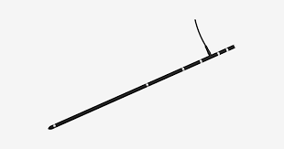

https://www.metergroup.com/en/meter-environment/products/teros-06-soil-temperature-profile-probe

SPECIFICATIONS
Dimensions:
Length: 104.0 cm (40.9
Diameter: 2.0 cm (0.79 in)

Operating Temperature Range:Minimum –30 °C
Maximum 60 °C

Supply Voltage 3.9 VDC continuous - 28.0 VDC continuous
MEASUREMENT SPECIFICATIONS
Temperature: Range –20 to +50 °C
Resolution ±0.03 °C
Accuracy ±0.1 °C (0 to 30 °C) ±0.2 °C (–20 to 50 °C)

Measurement Depths: 5 cm, 10 cm, 20 cm, 30 cm, 50 cm, 100 cm

COMMUNICATION SPECIFICATIONS
Output
SDI-12 one-wire serial interface
• DDI serial communications protocol
• SDI-12 communications protocol
RS-485 two-wire serial interface (M12 connector only)
• tensioLINK serial communications protocol
• Modbus RTU communications protocol
Data Logger Compatibility
METER ZL6 data loggers and any data acquisition system capable of 3.9- to 28.0-VDC
power and serial interface with SDI-12 and/or RS-485 interface, Modbus RTU, or tensioLINK communication

JXCT soil tensiometer

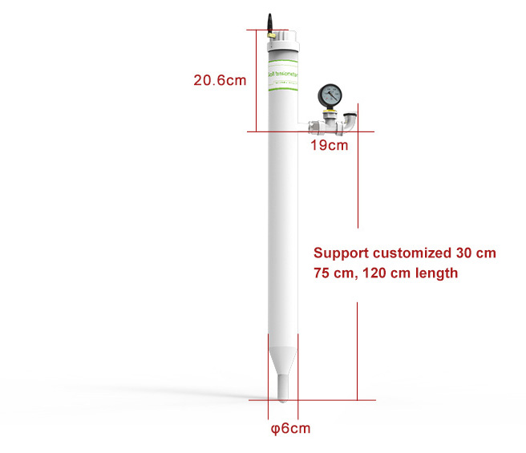
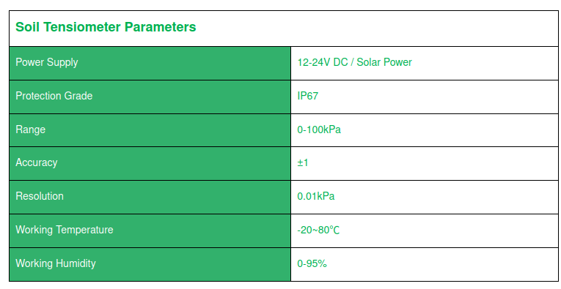

https://jxct-iot.com/product/showproduct.php?id=229

SENTEK drill and drop probe

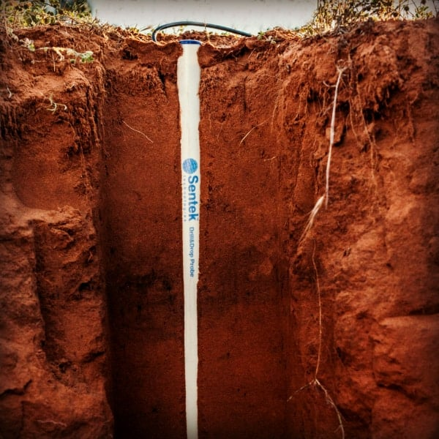
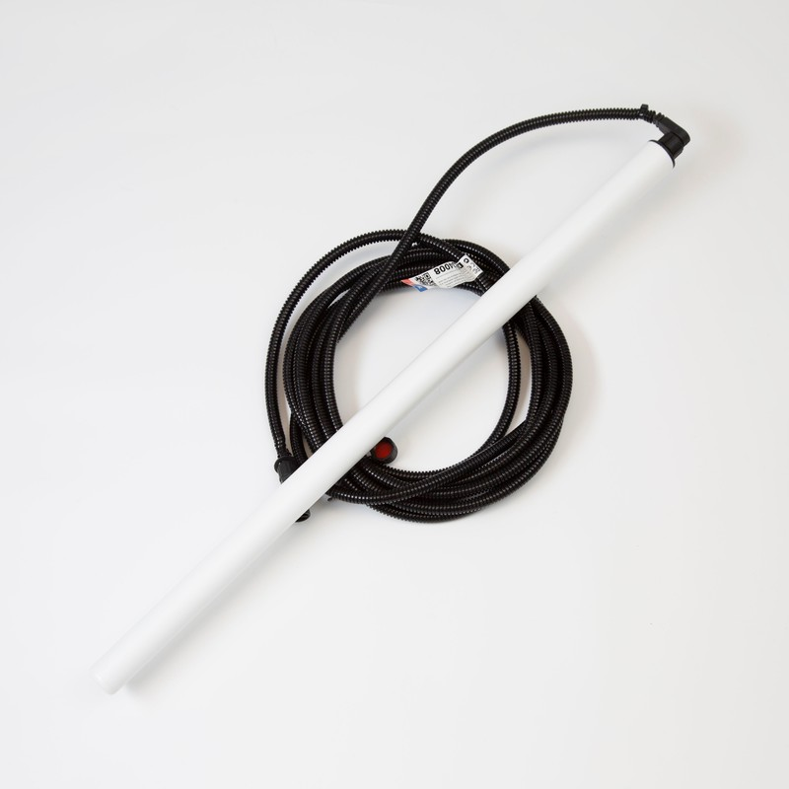

link to website : https://sentektechnologies.com/products/soil-data-probes/drill-drop/
patented technology

This probe can be used to measure soil moisture,salinity and temperature.the probe is fully encapsulated, easy to install and can be completely buried to reduce the risk of machinery damage.
*Salinity measurement capability is optional.
The Drill & Drop probe is available in lengths from 30cm (12 inch) through to 120cm (48 inch) with sensors every 10cm or four inches.

Tapered shape allows for extremely fast and high-quality undisturbed installation in majority of soil types.
- Ability to measure the true soil profile, NOT slurry.
- Buriable to any depth.
- Pre-normalised sensors with inbuilt default calibration equations.
- Access soil profile data through IrriMAX Live.
- Available with moisture, salinity and temperature sensors at every 10 cm (4 inches) depth.
Connectivity
Drill & Drop probes consists of a probe rod with integrated electronics and associated cables. Two probe types are available RS232/RS485 or SDI-12:
- RS232 communication to a Sentek PLUS DTU
- RS485 communication to a Sentek MULTI DTU
- RS232 or RS485 to a third-party Modbus logger
- SDI-12 communications to a third-party SDI-12 logger.
The Single Point Sensor is available with SDI-12 connection only, for communication to a third-party SDI-12 logger.
NEW! Series III Drill & Drop probes:
- The RS232/RS485 probe is preconfigured with the firmware appropriate to the DTU to which it will be connected i.e. Sentek PLUS, Sentek MULTI, Modbus RS232 or RS485 third party loggers.
- You can change the probe type (RS232 or RS485) by uploading new firmware into the probe (see manual for details)

- Irrometer:Watermark Soil Moisture Sensor customized lengths are available ,gather more data
- XLUX long probe deep soil moisture sensor ,40cm probe length

- HOBOnet multidepth VWC sensor.

